Supplies for Wet Felting a Small Flower
** If the wool gets wet during the layout stage, it is harder to work with, so always ensure that your hands are dry when working with wool roving. Use the edge of the table towel to dry your hands. **
- Plastic drop cloths and towels to protect your work surface.
- Small lengths of Merino wool roving in 2 to 4 colours: two in ‘flower’ colours and one or two in green. Each of the finished flowers weighs less than 6 grams. A ‘hank’ of wool roving the length of your elbow to your fingertips weighs approximately 10 grams.
- 1 to 2 flat, flexible plastic resists with a diameter of 24 cm. It can be a sturdy bin bag, bubble wrap, or builder’s underlay. (Of course, you can use resists with larger or smaller diameters).
- Small plastic water bottle with holes pierced in the lid or a sprinkler nozzle.
- Room temperature water and a drop of washing up liquid or liquid hand soap. (Soap helps in the felting).
- A piece of bubble plastic that is approximately 40 by 60 centimetres.
- Bucket or sink to rinse the project.
- Salad spinner or an old towel to help dry project.
- A small bottle of distilled white vinegar.
- For shaping, kitchen utensils such as chopsticks, wooden spoons, or mallets.
- Optional: Dedicated microwave or regular kitchen kettle. Adding heat to felt speeds up the shrinkage.

Simple Daisy Coaster – an introductory feltmaking project
Materials needed: one circle resist of approximately 16 cm in diameter. Two narrow ‘hanks’ of 5 grams each, for the base colour. There are approximately 20 cm long. The completed project should weigh less than 10 grams.
- The Layout Stage. Holding hands approximately 18 cm apart, pull thin shingles. Arrange on the template in a circular manner – like a bullseye, overlapping each shingle. Try not to go beyond the edge of the template. See the illustration below.

- Second Layer. Next, take your second flower colour and pull a thin shingle. Arrange radiating out from the centre of the circle. Continue adding ‘rays’ of wool so that the first colour is covered. (These rays may extend beyond the template). Then add an extra layer alongside the edge, following the curve of the circle. Pat inward to tidy.
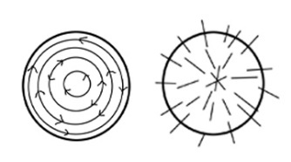
- Flower Time! Place the pre-cut, prefelt petals onto the circle. In the sample there are seven. You can use one or multiple colours for the petals. Place a small prefelt circle in the centre. It can be a contrasting colour.

- Wetting Stage. With dry hands, put the unused wool away from your project. Then, sprinkle a little soapy water on to the flower. Cover the top of the project with bubble wrap and press down to spread the water. Open and check to see if all the fibres are wet. Add more water if needed.

- Rub-a-Dub Stage. Cover with bubble wrap and sprinkle a tiny bit of water on top of the plastic. Using the tiny piece of bubble wrap, from the centre, rub out to the edges. Rub for two minutes. Open and check that nothing has shifted. Carefully push in or fold in the spread-out edges so that the project is the size of the resist template.

- Rolling Stage. Cover with bubble wrap and place the dowel parallel to your stomach. Roll the project up from the edge closest to you like a jelly roll. Roll 25 times. Unroll, turn a quarter, and roll it up for another 25 times. Turn the project each time, a quarter turn – North, East, South, West. You should do approximately 100 rolls. Then, remove the resist. Flip over. And roll some more! Felt Shrinks in the direction that it is agitated/rolled, so this rolling encourages the fibres to shrink.

- Fulling (Shrinking) Stage. Open the bubble wrap. Fold the circle of prefelt into half, then fold it again. Throw this small bundle onto the table 10 times, changing sides. Refold and repeat. Roll the felt onto itself, using the tips of your fingers. Massage it. Depending upon uses, felt should be shrunk to at least 35% of its original layout. Ideally, it should be shrunk down 40-45%. Otherwise, it will not hold up; there will be pilling. With our flower, let’s try to shrink it to half of the original layout or the size of a drink’s coaster. Be patient, this step can take some time. Note: Heat can help speed up the fulling stage. There are two ways to achieve this: by heating for 1 minute in a dedicated craft microwave or by pouring almost boiling water from a kettle on to your project. Both activities should be done with care! Add more soap if using the kettle method.

- Tidy Up! This step is optional. Using sharp scissors tidy up the wavy edges on the perimeter. Now it’s time to heal the cuts – rub along the edges, parallel. Roll the flower between your hands. Roll the petals side to side. Pull on the edges where needed, so that the shape is an even circle. Make sure everything is soapy and wet otherwise your project can get fuzzy.

- Rinsing Stage. Rinse in room-temperature or warm water. It usually takes three rinses until the water runs clear. Squeeze water out.

- Vinegar Rinse. Put 1 tablespoon of distilled vinegar in a small bucket of room-temperature water. Let sit for 10 minutes. Let drip back in (as it can be reused). A vinegar rinse helps to remove soap and bring the PH back to acid.

- Almost Done! Blot your flower on a clean towel. Re-shape and let dry.

Lily with Stem – a three-dimensional layout feltmaking project
Materials needed: 1 bud-shaped resist. 2 hanks of flowered coloured wool 20 cm in length. A tiny bit of green wool roving for the stem. The completed project should weigh less than 10 grams.
- Layout First Layer. Using a bud-shaped resist, layout green-coloured fibres over the stem. See the illustration below. Then, layout flower Colour 1 at the base, and Flower Colour 2 at the tip of the flower. The fibres should extend past the resist. Wet and flip over. Then, carefully fold over the overlapping fibre. Next, fill in the areas in the centre that don’t have enough wool.

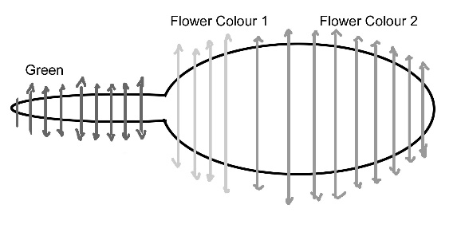
- The Second Layer. On the stem area, use green wool. For the flower, use one colour. You can use a contrasting colour at the very tip of the bud. See the illustration below.
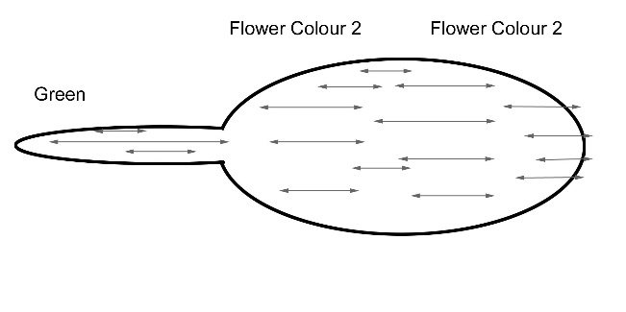

- Rub-a-Dub Stage. Lightly sprinkle with soapy water. Press the bubble wrap down on top to help distribute the water. Open the bubble wrap and carefully, spread the netting over of the flower. With a small piece of bubble wrap, lightly rub through the netting. Unwrap and check that wool is hugging the resist. Otherwise, an unattractive bulge may develop. Flip over and cover with net and rub this side. Rub along the edges so that the wool hugs the resist. Continue until the wool does not shift when you gently poke it with a finger. Lift the netting often so that it does not become felted into the project.

- Rolling Stage. Enclose the project in the bubble wrap, with the felt closest to the fold. Place the dowel parallel to your stomach. Roll up the project like a jelly roll. Then, roll the bundle 25 times. Unroll and check. Rotate the bud so it faces North-South; cover and roll again 25 more times. Then, turn it so it is East-West and roll 25 more times. Continue rolling until the fibre holds together. You can flip it over and roll it from its other side. Roll approximately 100 times.

- Shrinking (or Fulling) Stage. When the fluff begins to hold together, you can massage it with your hands. Roll it like a snail, from the tip to the stem. Then change directions. Roll the stem to make it more compact.

- Crash and Bash Stage. Continue to agitate the wool by throwing it down on the table. As the wool shrinks and gets smaller, the plastic resist will bubble up as it has nowhere to go. This is not an issue. Heat from a dedicated microwave can help assist in speeding up the shrinkage. Zap for one minute and use care when removing as the project will be hot!

- Removing the Resist. With sharp scissors, carefully make a small slit at the tip of the bud. AVOID cutting the plastic resist. Remove the resist – use a chopstick to get at it. You can add two short vertical cuts to make petals. With soapy fingers, rub the cut edge to heal. Continue to rub/roll/massage until the wool has shrunk to almost half the original layout's size.

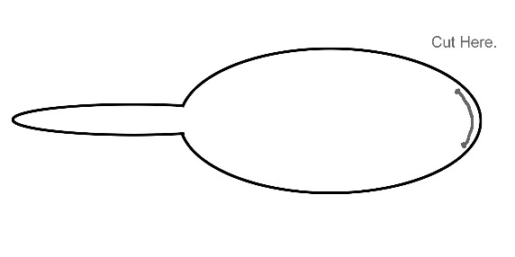
- Sculpting Stage. Shape by rolling between your fingers. Stretch and pull to make parts broader or longer. Use a chopstick or a spoon to get inside the project. This is the Fun Stage!

- Rinsing Stage. Rinse out the soapy water until the water runs clear. It usually takes at least three changes of water.

- Vinegar Rinse. Put 1 tablespoon of distilled vinegar in a small bucket of room-temperature water. Let sit 10 for minutes. Lift and let the liquid drip back in (as the vinegar water can be reused). A vinegar rinse helps remove soap and brings the PH back to acid.

- Almost Done! Blot dry on a clean towel. Re-shape and let dry.

The Cupped Flower with Leaves – an advanced feltmaking project
Materials needed: 2 disk-shaped resists, approximately 24 cm in diameter. One of the resists has a ‘doughnut’ hole in the centre. One slender, 5 gram hank of green roving, and two 5 gram hanks of flower coloured roving, approximately 20 cm in length. The completed project should weigh less than 10 grams.
- Peace Sign Leaves. Take the white plastic resist and a short narrow hank, approximately 20 cm of green. Put some wisps of contrasting green down for 3 triangular leaves. Then do a second layer of short green fibres across these triangles. You can vary the colours of green. See illustration below. Then, set this aside.
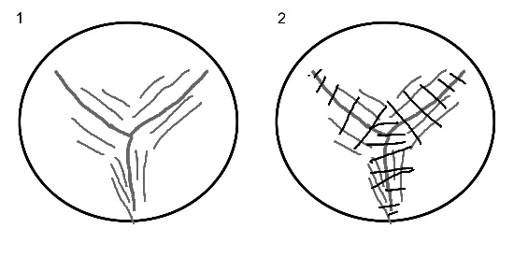

- Making the Eclipse. Take the black doughnut resist and lay it on the bubble wrap. Take a tiny wisp of green wool and break it into very short lengths. Hold the wool, with your hands close to each other to snap short lengths. Then, radiating out from the centre, layer some wispy thin roving along the edge of the bull’s eye hole in the centre. Slightly dampen. Cover with the bubble wrap, bubble side down and press to distribute the moisture. Open up the bubble wrap. Flip over and gently peel the wool from the centre. Then, peel it over to the edge of the hole on the front side. It doesn’t need to look pretty. See illustration below.

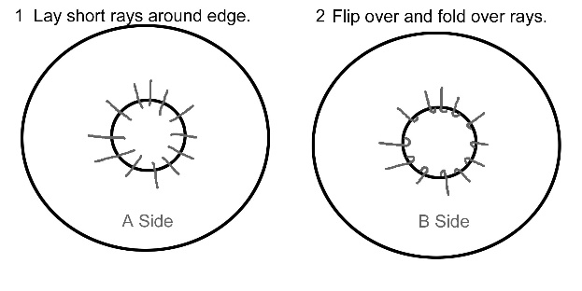
- Lightly moisten the green-coloured, Peace Sign Leaves. Then, place the Eclipse on top of the Peace Sign Leaves.

- Dry your hands. Tear short lengths of green wool and fill hole in centre. Lay them down so they cross in different directions. This will help with attach the layers.

- Blossom Layout. Take two narrow hanks of approximately, 20 cm of in two different flower colours. They can be similar or contrasting colours. With your hands spread 20 cm apart, pull a thin ‘shingle’ of wool. Place this on the black resist to follow the circle's curve. Then, take the second flower colour and radiate the fibres out from the centre. Try not to extend past the edge of the black plastic. To decorate,pull a wisp of the first colour and make a loop. Lay it in the centre. You can use wisps of the leaf colour if you like. Or for contrast, use a thin strip of the first flower colour along the inner edge – see Step 3 below in the illustration.

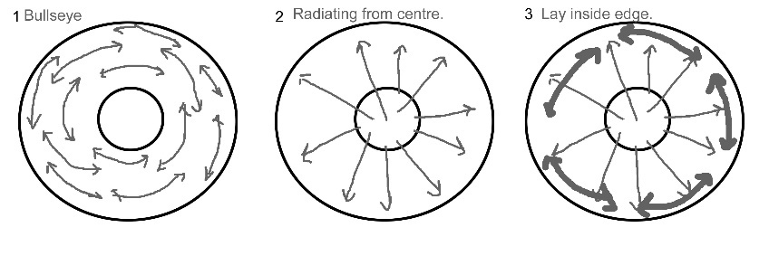
- Wetting Stage. Lightly wet down and fold the bubble plastic on top of your project, bubbles facing down.

- Rub-a-Dub Stage. Wet the top of the bubble plastic and rub for a while – rub over the centre part. (You can use netting. Just be careful that it does not felt into the wool). After 2 minutes of rubbing, check to see that the fibres do not shift by gently poking with a fingertip.

- Rolling Stage. Place project near to you on the bubble wrap. Fold the bubble wrap over it. Then place a dowel parallel to your body and roll up bubble wrap like a jelly roll. Roll 25 times. Then unroll and reposition the dowel at a right angle. Roll up the bubble wrap and roll from this direction. Flip the project over and continue rolling 25 times in each direction - North, East, South, and West. Rolling helps the fluffy fibres to tangle and start to felt. Wool shrinks in the direction that it’s rolled.

- Fulling (or Shrinking) Stage. With wet hands, massage and knead. Throw it down onto the table ten times, changing the position of the felt each time. This may give an elephant-skin texture.

- More Agitation. Make sure the project is still wet and soapy and rub it on itself. Fold the flower in half and rub the two halves side to side. Varying the types of agitation helps to shrink the felt. ** You should shrink the flower to nearly half the size of the original layout – ideally 35 to 45%. If felt that is not shrunk enough, ends up not holding up as well. It will pill. **

- Shaping Stage. Hold down at the centre and gently pull upwards to stretch to shape the petals. Use kitchen tools to poke, prod, and sculpt. Then roll the blossom upon itself – again.

- Rinsing Stage. Rinse in warm water until the water runs clear – approximately three changes of water.

- Vinegar Rinse. Put 1 tablespoon distilled vinegar in a small bucket of room temperature water. Let it sit for 10 minutes. Allow it to drain back into the bucket, as you can reuse the vinegar rinse.

- Almost Done. Blot on a clean towel. Shape and let dry.

Each of the projects has an accompanying YouTube video on the Feltmakers Ireland Channel -
https://www.youtube.com/@feltmakersireland
The Daisy Coaster - https://youtu.be/9DeUoi3XEn0?si=9tT_nL4Czn_PNoAH 
The Lilly Bud - https://www.youtube.com/watch?v=MwGIXISQcRo&t=3s 
The Cupped Flower - https://www.youtube.com/watch?v=CB8MJNi589g&t=20s 

