FELTMAKERS IRELAND
Nuno Felting 1 Workshop
Elizabeth Bonnar
Suitable for those who have some experience of felt making.
The morning will be spent learning the basic principles of Nuno felt
and exploring many different techniques,through sample making.
The afternoon will be given over to making a scarf of the participant’s own design.
15th June 2019 10:00am - 5:00pm
Venue: RATHMICHAEL Church of Ireland National School, Stoneybridge Road, Shankhill, Dublin.

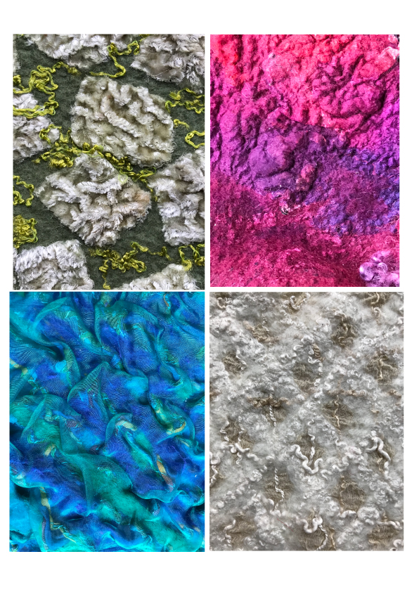
For further information contact hello@feltmakersireland.com
Deadline for receipt of applications is 1st June 2019. The maximum number of participants is 12. If the workshop is oversubscribed, priority will be given to members and names will be drawn from a hat
No refunds for cancellation after 5th June

…………………………………..…………………………………..

Feltmakers Ireland Nuno Felting- with Liz, Workshop
15th June 2019
Cost of Workshop - Member €55 (please ensure your membership is up to date) Non-Members € 80

Name ………………………….………………………………

Address…………………………………………………………………….....

Tel…………………………. email………………………………………..

We look forward to hosting you- Payment details

PAYMENT DETAILS
We prefer Payment by Electronic Transfer:
IBAN: IE09 AIBK 9311 3603 9910 75 BIC: AIBKIE2D (with your name)

Please on payment add your name in the “message” as we will check this off against the application forms.

Application forms can be emailed to
workshop@feltmakersireland.com

If sending via post please mail to:
Nuno Felting Workshop
4 The Grove
Moyglare Hall
Maynooth
Co.Kildare
W23 NR86

Cheque/ Postal Order
If paying by cheque, please make cheque/PO payable to Feltmakers Ireland and forward to:
Nuno Felting Workshop
4 The Grove
Moyglare Hall
Maynooth
Co.Kildare
W23 NR86

MATERIALS REQUIRED:
MATERIALS:
Fabrics for the different samples will be provided.
For scarf making, participants may bring along their own fabric( see details below ) or purchase on the day from a variety of fine fabrics which will be available.
Participants are asked to bring their own wool fibre, which should be no more than 18 microns, to provide a predictable outcome.
A selection of wool and silk fibre, fabrics, and yarns will be provided to use as embellishment; participants may also bring their own.
EQUIPMENT:
Towels
Bubblewrap
Soap - olive oil soap preferred.
Roller
Water sprinkler
Plastic bowl
Notebook
Scissors
Rubber gloves - optional
Apron
Plastic bags for damp felt or towels.
YOUR OWN MUG

FABRIC FOR SCARVES:
Participants should bring a meter of silk chiffon or fine paj to ensure a good result ; with synthetic fabrics and heavier weight silk however the result is not always predictable.

