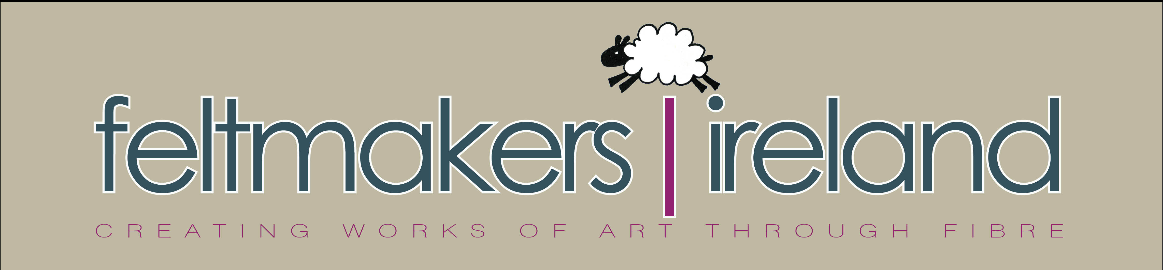

Joint Exhibition with Finnish Felt Association Filtti and Feltmakers Ireland

Title; Something Red

Exhibition Application Form
All submissions must arrive on or before March 15th 2019. The Selection Committee meets at the end of March. If selected in the first round, you will be asked to submit your actual piece for further adjudication by 22nd April.
PLEASE INDICATE THE DIMENSIONS OF THE PIECE:___________________
Artist/Exhibitor: ____________________________________________________________________
Address: __________________________________________________________________________

Phone: ________________________________ Email:

______________________________________

- Name of Piece and brief description_______________________________________

- Name of Piece and brief description_______________________________________

__________________________________________________________________________

- Name of Piece and brief description_______________________________________

__________________________________________________________________________

Submit up to 5 digital images of each piece. Please take time to take good photos of your work.
There are two ways to submit images:
1.digital images attached to this doc- email
2. photo prints of at least 4”x 6” along with title, medium and size- physical photo sent to address below.

*Note: DO NOT SEND ACTUAL WORKS OF ART, ONLY DIGITAL OR PHOTO REPRODUCTIONS. FELTMAKERS IRELAND WILL NOT BE RESPONSIBLE FOR LOST OR DAMAGED SUBMISSIONS.
Send completed form and attached images and information to:
Exhibition Selections, Maureen Cromer .Hillsboro. Lucan Rd. Leixlip. Co. Kildare
Email; hello@feltmakersireland.com

